Year 3 Forces and magnets Physics (Autumn 1)
Key Knowledge

Magnets have north and south poles. When two magnets are close, they create pushing or pulling forces on one another.
- Same poles repel
- Different poles attract

Magnetic poles
What is a ‘force’?
A force is a ‘push’ or a ‘pull’. Some forces need to come into contact whereas other do not (like magnets). Forces can make things move, change shape or change direction. For example, kicking a ball is a push force.
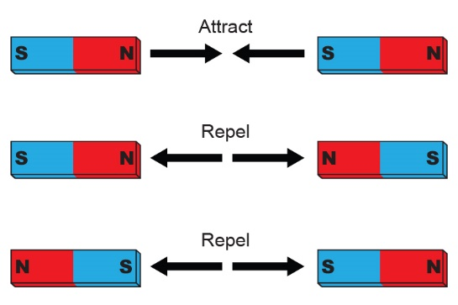
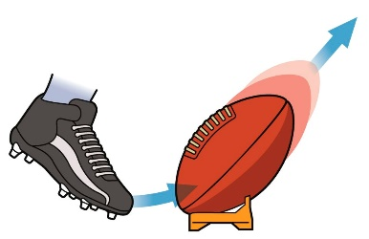
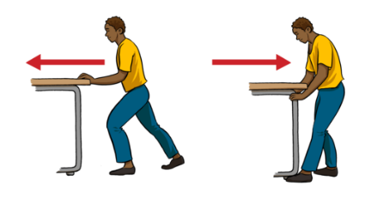

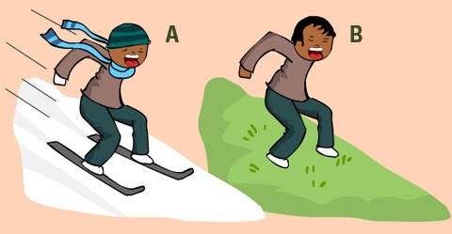
Some surfaces are easier to slide over than others. The force that stops the sliding is called friction. Smooth surfaces are easier to slide over than rougher surfaces.
Friction
Key Vocabulary
force | A force is a push or pull on an object.
friction | Friction is a force between two surfaces that are sliding, or trying to slide, across each other.
magnet | A magnet is an object (usually metal) that is made of materials that has magnetism.
magnetism | Magnetism is a force experienced by certain metals. It can make the metal repel or attract.
attract and repel | When magnets attract they pull together; when they repel, they push away from each other.

