COMPUTING SPREADSHEETS YEAR 4 AUTUMN
average | Symbols used to represent comparing two values.
advance mode | A mode of 2Calculate in which the cells have references and can include formulae.
copy, cut and paste | Contents of cells can be copy and pasted or cut and pasted. Use ctrl+c to copy and ctrl+v to paste.
columns | Vertical reference points for the cells in a spreadsheet.
cells | An individual section of a spreadsheet grid. It contains data or calculations.
charts | Use this button to create a variety of graph types for data in the spreadsheets.
equals tool | Tests whether the entered calculation in the cells to the left of the tool has the correct answer in the cell to the right of the tool.
formula | Use the formula wizard or type into the formula bar to create a formula in a cell, this will calculate the value for the cells based upon the value of other cells in the spreadsheet.
formula wizard | The wizard guides you in creating a variety of formulae for a cell such as calculations, totals, averages, minimum and maximum for the selected cells.
move cell tool | This tool makes a cell’s contents moveable by drag-and-drop methods.
random tool | Click to give a random value between 0 and 9 to the cell.
rows | Horizontal reference points for the cells in a spreadsheet.
spin tool | Adds or subtracts 1 from the value of the cell to its right.
timer | When placed in the spreadsheet, click the timer to adds 1 to the value of the cell to its right every second until it is clicked again.
Key Vocabulary
Key Images
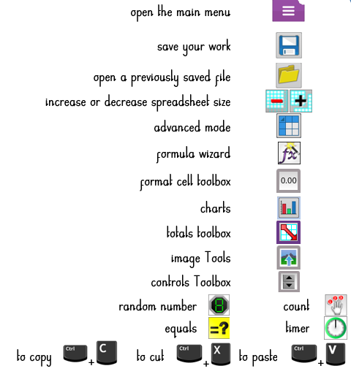
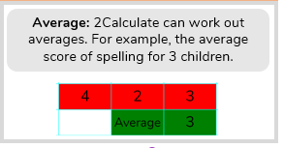
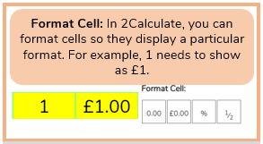
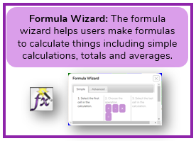
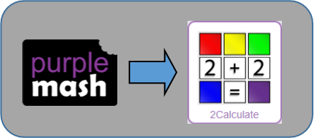
Resources
Key Knowledge

