Year 3 Animals including humans Biology (Autumn 2)
Key Knowledge

All animals need the correct nutrition to be healthy. Humans need a balance of vegetables, proteins, fats, dairy and carbohydrates.
What is a skeleton for?
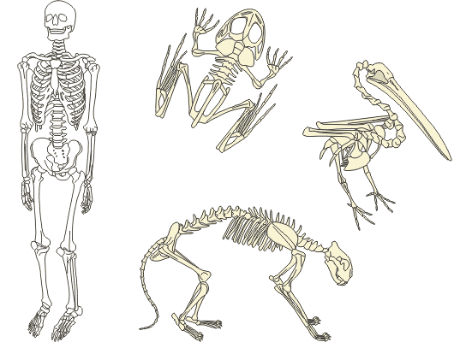
Vertebrates and Invertebrates
Nutrition

Some animals have a backbone (spine). These are called vertebrates. Some do not, these are called invertebrates.
- Movement
- Support
- Protection
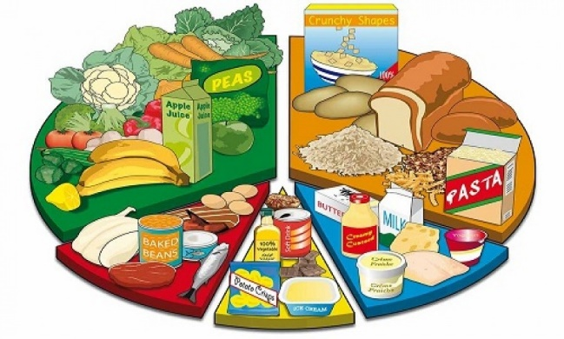
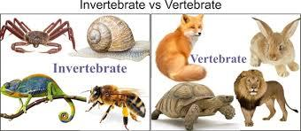
Skeletons are a framework of bone (or other material) that helps to protect an animal, help it to move and to support its body.

nutrition | The process of providing or obtaining the food necessary for health and growth. | carbohydrates | A large group of food which contain mainly starch.
Vertebrates/ invertebrates | Animals with a spine are called vertebrates, those without are called invertebrates. | proteins | A large group of goods that are essential for body tissues.
skeletal system | An internal or external framework of bone, cartilage, or other rigid material supporting or containing the body of an animal. | dairy | A group of foods containing or made form milk.
exoskeleton | A rigid external covering for the body in some invertebrate animals, especially arthropods. | fats | A food group high in energy content that provides essentials nutrients.
Key Vocabulary

