COMPUTING ONLINE SAFETY YEAR 4 AUTUMN
computer virus | A piece of code which can copy itself and typically has a damaging effect on the device, such as corrupting the system or destroying data.
cookies | A small amount of data generated by a website and saved by a web browser. Its purpose is to remember information about the user.
copyright | When the rights to something belong to a specific person.
digital footprint | The information about a person that exists on the Internet as a result of their online activity.
email | Messages sent by electronic means from one device to one or more people.
identity theft | When a person pretends to be someone else.
malware | Software that is specifically designed to disrupt, damage, or gain unauthorized access to a computer system.
phishing | Emails that pretend to be from reputable companies in order to persuade individuals to share personal information, such as passwords and credit card numbers.
plagiarism | When you use someone else's words or ideas and pass them off as your own.
spam | Messages sent over the Internet, typically to many users, for the purposes of advertising, phishing or spreading malware.
Key Images
Key Vocabulary
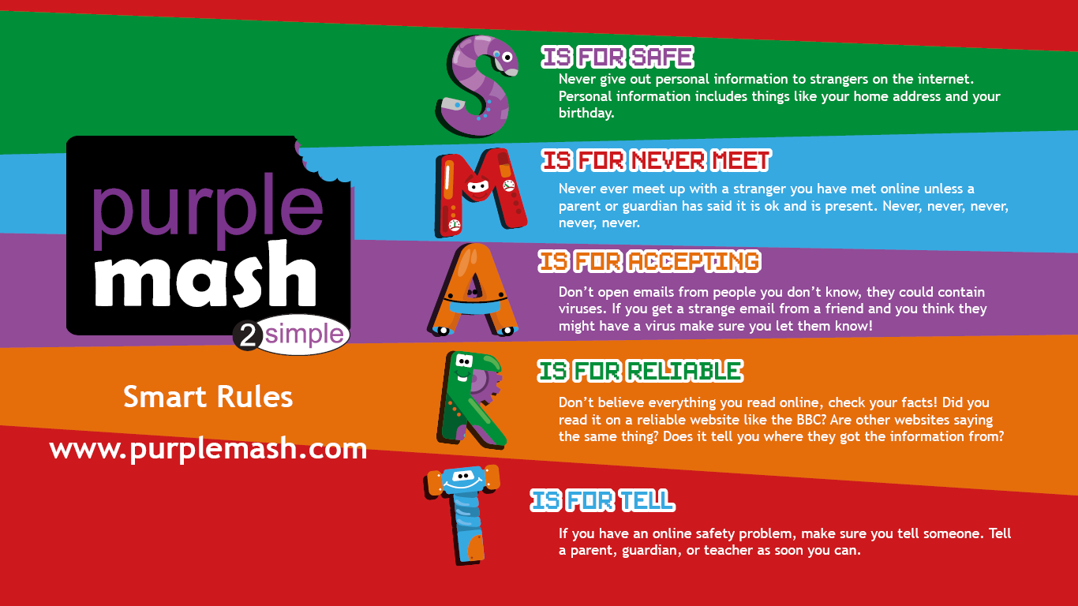

Key Knowledge
Resources
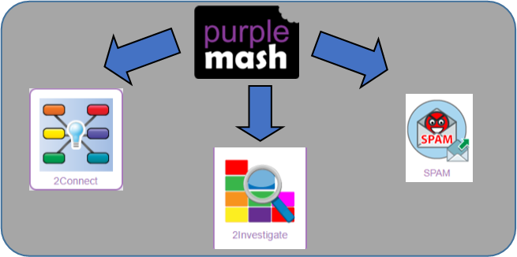

SPAM messages are emails or online messages sent from a computer to many other users. The users are sent the email without requesting it. The purpose of SPAM is for advertising, phishing or malware. |  | Plagiarism refers to using someone else’s work and claiming it to be your own.

Key Knowledge

