COMPUTING ONLINE SAFETY YEAR 3 AUTUMN
blog | A regularly updated website or web page, typically one run by an individual or small group, that is written in an informal or conversational style.
concept  map | A diagram that shows how different objects or ideas are related and connected.
internet | A way to send information from one computer to another anywhere in the world using technology such as phones, satellites and radio links.
password | A secret word, phrase or combination of letters, numbers and symbols that must be used to gain admission to a site or application such as a website.
PEGI rating | A rating that shows what age a game is suitable for.
spoof website | A website that uses dishonest designs to trick users into thinking that it represents the truth.
webpage | A page online that makes up one screen of a website.
website | A set of related web pages located under a single name.
username | An identification used by a person with access to a computer, network, or online service.
Key Images
Key Vocabulary
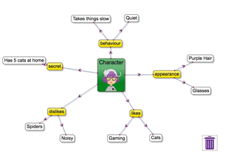 | 2Connect screen with nodes added
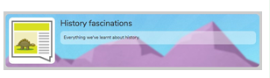 | blog header
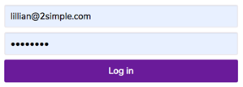 | username and password screen

Key Knowledge
Resources

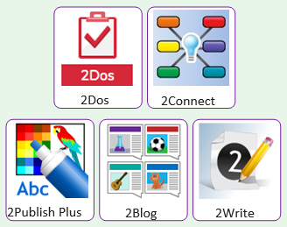

Just because something is on the Internet doesn’t mean that it is true. Some people create spoof websites that pretend to be something else such as a bank website or to provide misleading information. | Computer games, like films, are often not suitable for children. PEGI ratings will show how old a person must be to play a game.  