Nursery | 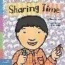  Sharing Time  by Elizabeth Verdick  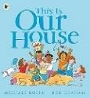  This Is Our House  by Michael Rosen  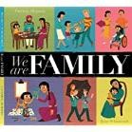  We are Family  by Patricia Hegarty  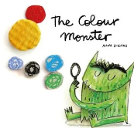  The Colour Monster  by Anna Llenas  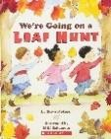  We are Going on a Leaf Hunt  by Steve Metzger  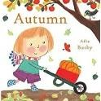  Autumn  by Ailie Busby  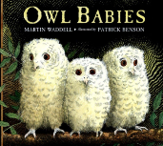  Owl Babies  by Martin Waddell    Whatever Next  by Jill Murphy    Let's Celebrate 5 Days of Diwali!  by Anjanta Chakraborty & Vivek Kumar    Bonfire Night Poem    A Kipper’s Christmas Eve  by Mick Inkpen  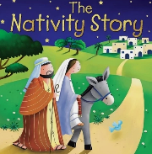  Nativity Story  By Juliet David | 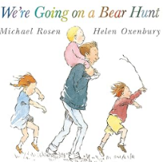  We’re Going on a Bear Hunt by Micheal Rosen  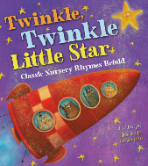  Twinkle Twinkl Little Star  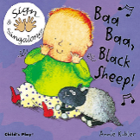  Baa Baa Black Sheep  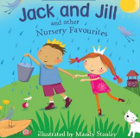  Jack and Jill  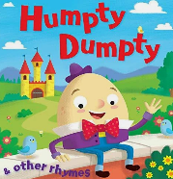  Humpty Dumpty  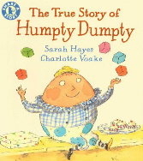  The True Story of Humpty Dumpty  By Sarah Hayes and  Charlotte Voake  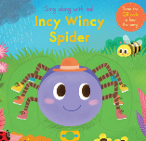  Incy Wincy Spider  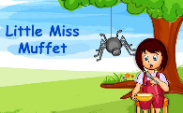  Incy Wincy Spider  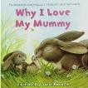  Why I Love My Mummy  by Daniel Howarth  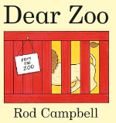  Dear Zoo  By Rod Campbell  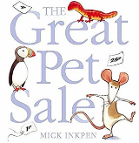  The Great Pet Sale  By Mick Inkpen  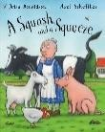  A Squash and a Squeeze  by Julia Donaldson  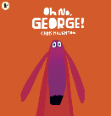  Oh No George  Chris Haughton  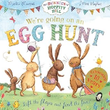  We’re Going on an Easter egg Hunt  By Martha Mumford | 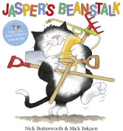  Jasper’s Beanstalk  By Nick Butterworth and  Mick Inpen  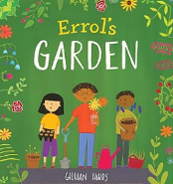  Errols Garden  By Gillian Hibbs  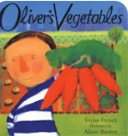  Oliver’s Vegetables  By Vivian French  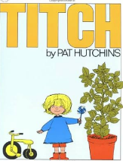  Titch  By Pat Hutchins  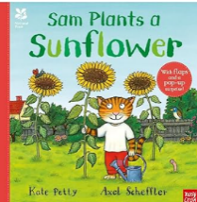  Sam plants a Sunflower  By Katy Petty  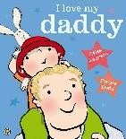  I Love my Daddy  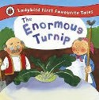  by Giles Andreae  The Enormous Turnip  By Irene Yates  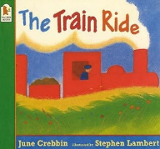  The Train Ride  by June Crebbin  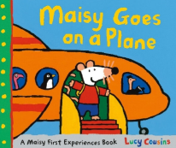  Maisie Goes By Aeroplane  By Lucy Collins  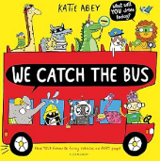  We catch the bus  By Katie Abey  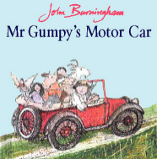  Mr Gumpy’s Motor Car  By John Burningham  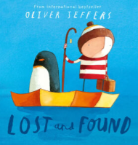  Lost and Found  By Oliver Jeffers  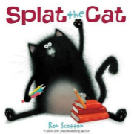  Splat the Cat  By Rob Scotton
Nursery rhymes | If you’re Happy and You Know It  Wind the Bobbin Up  Autumn Leaves  5 Little Monkey’s Jumping on the Bed  Miss Polly Had a Dolly | Dingle Dangle Scarecrow  Little Bo Peep  5 Little Speckled Frogs  Mary, Mary… | 1,2,3,4,5 Once I Caught a Fish Alive  Here is the Beehive  Down at the Station  The Wheels on the Bus

Reception | The Colour Monster  By Anna Llenas  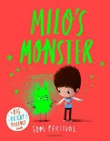  Milo’s Monster  By Tom Percival  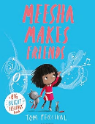  Meesha Makes Friends by Tom Percival  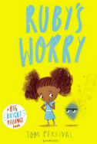  Ruby’s Worry  By Tom Percival  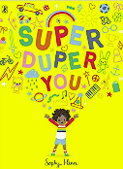  Super Duper You  By Sophy Henn  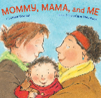  Mommy, Mama and Me  By Leslea Newman  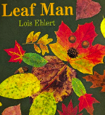  Leaf Man  By Lois Ehlert  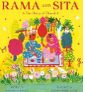  Rama and Sita  By Malachy Doyle    Man on the Moon  By Simon Bartram  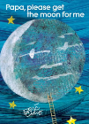  Papa, Get me the Moon  By Eric Carle  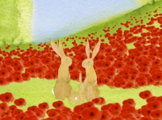  Poppies  CBeebies  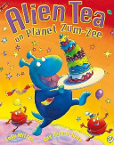  Alien tea on Planet Zum Zee  By Tony Mitton  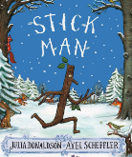  Stickman  By Julia Donaldson  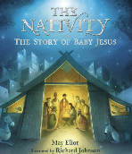  The Nativity  By Eliot May | 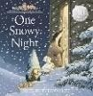  One Snowy Night  Nick Butterworth  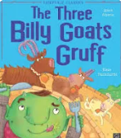  The Three Billy Goats Gruff  Mara Alperin  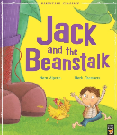  Jack and the Beanstalk  Mara Alperin  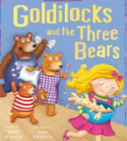  Goldilocks and the Three Bears  Mara Alperin  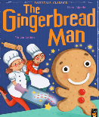  The Gingerbread Man  Mara Alperin  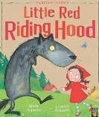  Little Red Riding Hood  Mara Alperin  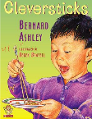  Cleversticks  Bernard Ashley    Mad About Dinosaurs  By Giles Andreae  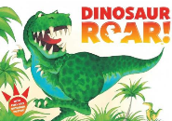  Dinosaurs Roar  By Paul Stickland  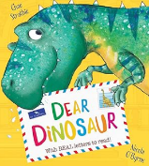  Dear Dinosaur  By Chae Strathie  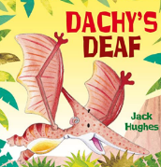  Dachy’s Deaf  By Jack Hughes  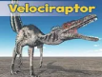  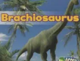  Non-Fiction  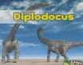  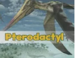  All About Dinosaur  By Daniel Nunn  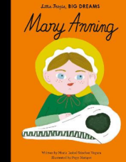  Little people big dreams Mary Anning  By Maria Isabel Sanches Vegara  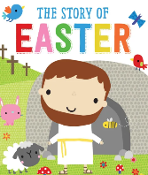  The Story of Easter  By Fiona Boon | 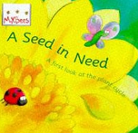  A Seed in Need  By Sam Godwin  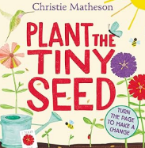  Plant the tiny Seed  By Chistie Matheson  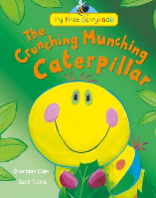  The Crunching Munching Caterpillar  By Sheridan Cain  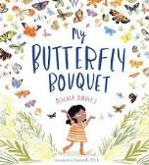  My Butterfly Bouquet  By Nicola Davies  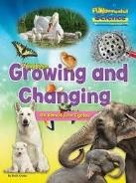  Growing and Changing All About Life Cycles by Ruth Owen  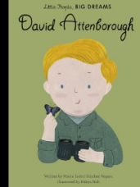  Little people big dreams David Attenborough  By Maria Isabel Sanches Vegara  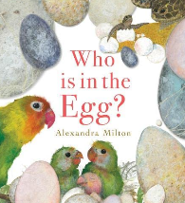  Who’s in the Egg?  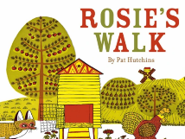  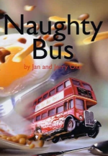  By Alexandra Milton  The Naughty Bus  By Jan and Jerry Oke  Rosie’s Walk  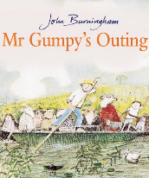  By Pat Hutchins  Mr Gumpy’s Outing  By John Burningham  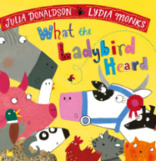  What the Ladybird Heard  By Julia Donaldson

Nursery rhymes | Hey Diddle Diddle  Old King Cole  Head Shouolders Knees and Toes  5 little men in a Flying saucer  12345 Once I caugt a fish alive | 5 Little ladybirds  I had a little Nut Tree  Ding Doong Bell  There was a Crooked Man  When Goldilocks went to the house of the Bears | Theres a tiny Caterpillar on a leaf  Theres a worm at the bottom of the Garden  Here is a Beehive  5 little Peas in a Pea pod press  Ten in a Bed  Ten Green Bottles

